Task 1: Configure Classic Load Balancer (CLB)

Objective
Create a Classic Load Balancer to distribute incoming HTTP traffic across multiple EC2 instances, improving application availability and reliability.

Prerequisites
- AWS Account
- VPC created
- Minimum 2 EC2 instances running in different Availability Zones
- Web server installed (Apache/Nginx/Tomcat)
- Security Group allowing:
  - HTTP (80)
  - SSH (22)
- Instances must pass Health Checks

Implementation Steps

Step 1: Login
Login to AWS Management Console.

Step 2: Navigate
EC2 Console
→ Load Balancers
→ Create Load Balancer

Step 3: Select
Choose
Classic Load Balancer
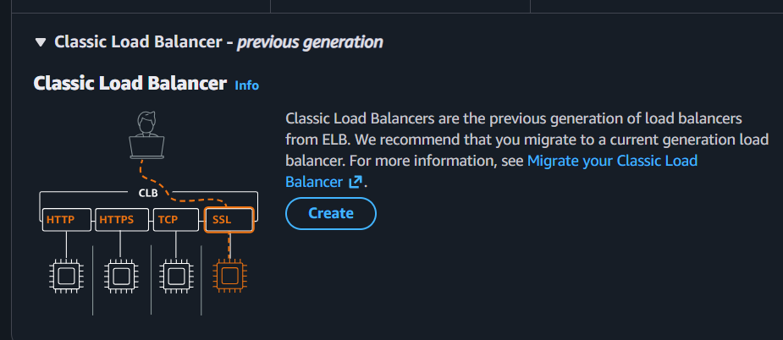
Click Create

Step 4: Basic Configuration
Enter
- Name
- Scheme
  - Internet-facing
- IP Address Type
  - IPv4
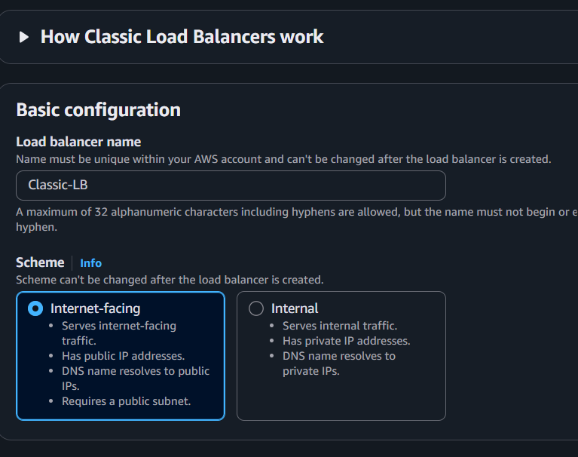

Step 5: Listener Configuration
Add Listener
Protocol | Port
HTTP | 80
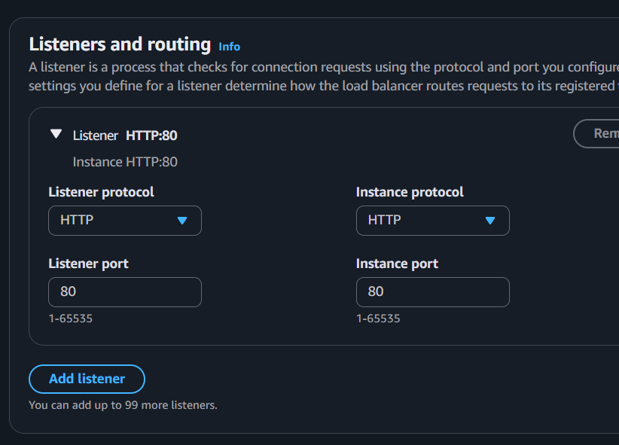

Step 6: Network Mapping
Select
- VPC
- Availability Zone A
- Availability Zone B
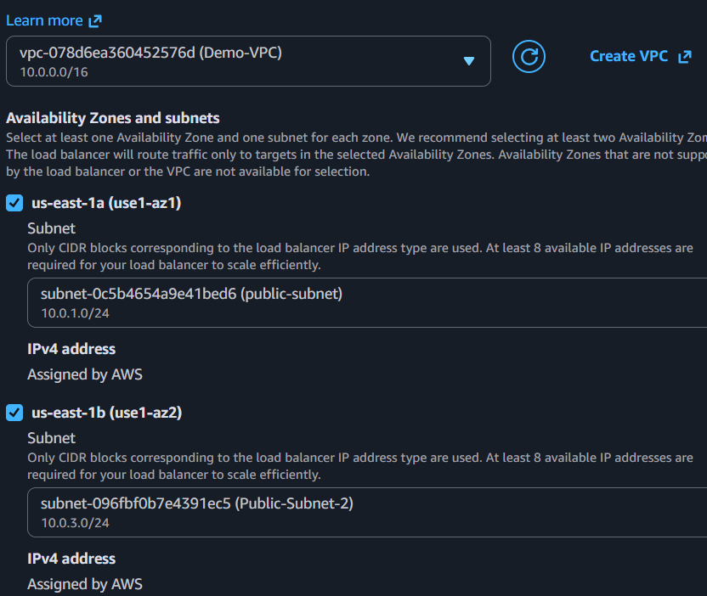

Step 7: Security Group
Choose an existing security group allowing
- HTTP 80
- HTTPS 443 (optional)
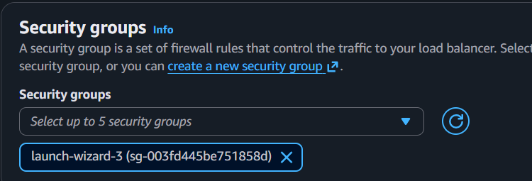

Step 8: Configure Health Check
Example
Protocol : HTTP
Ping Port : 80
Ping Path : /
Healthy Threshold : 5
Unhealthy Threshold : 2
Timeout : 5 sec
Interval : 30 sec
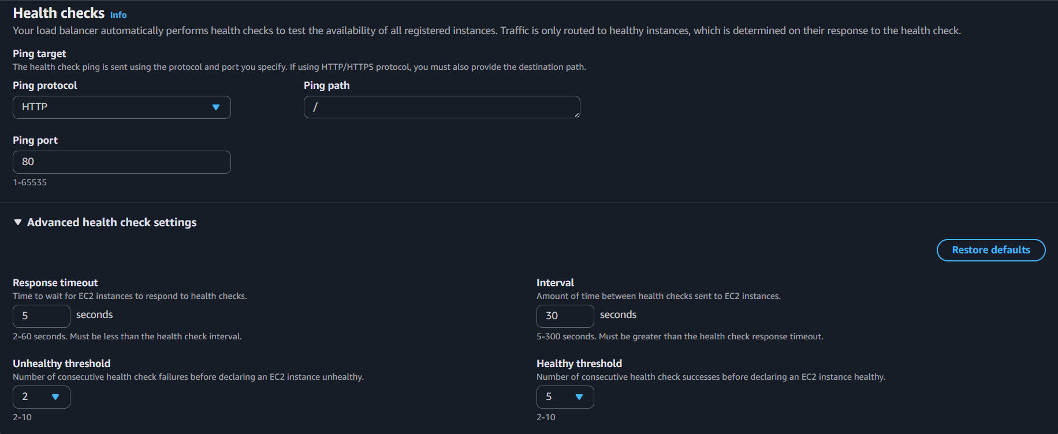

Step 9: Register Targets
Select
EC2 Instance 1
EC2 Instance 2
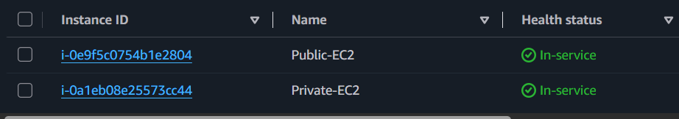

Step 10: Review
Click
Create
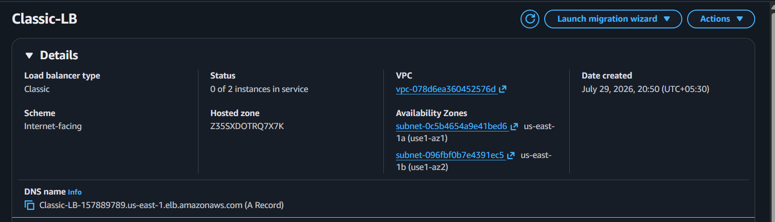

Step 11: Test
Copy the CLB DNS Name
Open browser
http://CLB-DNS-Name
Refresh multiple times.
Traffic should be distributed.
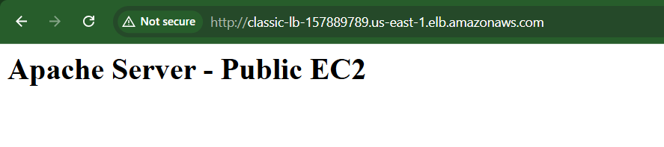


Outcome
- Classic Load Balancer created.
- Requests distributed across EC2 instances.
- High Availability achieved.
- Health checks automatically remove unhealthy instances.

Task 2: Configure Application Load Balancer (ALB)

Objective
Deploy an Application Load Balancer to distribute HTTP/HTTPS traffic intelligently using Layer 7 routing features.

Prerequisites
- VPC
- Two public subnets
- Two EC2 instances
- Target Group
- Security Group
- Web application running

Implementation Steps

Step 1
EC2 Console
Load Balancers
Create Load Balancer

Step 2
Select
Application Load Balancer

Step 3
Basic Configuration
Name
Scheme
Internet-facing
IP Type
IPv4
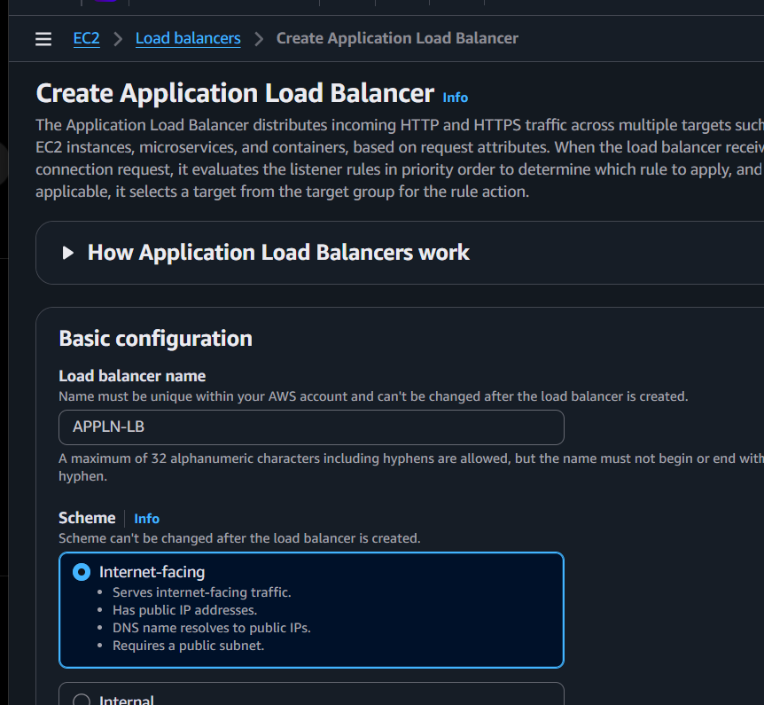

Step 4
Network Mapping
Select
- VPC
- Public Subnet 1
- Public Subnet 2
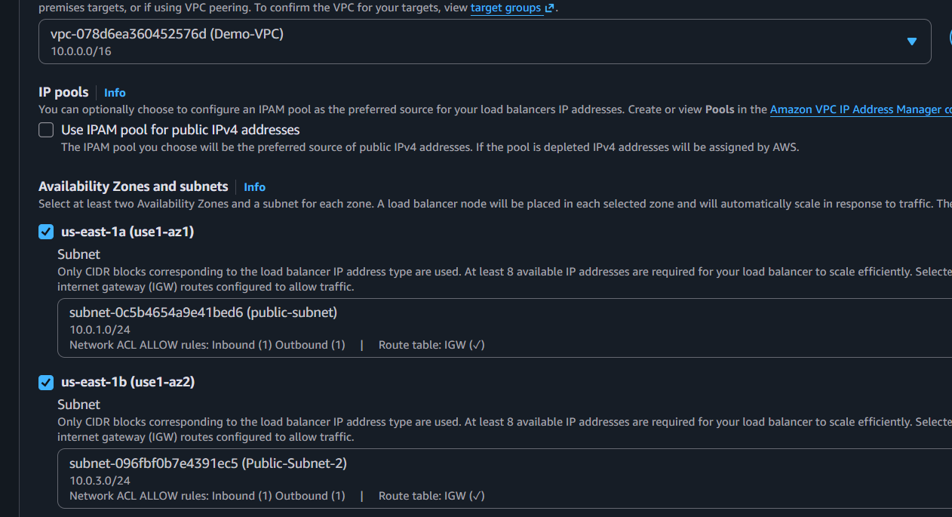

Step 5
Security Group
Allow
- HTTP 80
- HTTPS 443

Step 6
Create Target Group
Target Type
Instances
Protocol
HTTP
Port
80
Health Check
/
Register EC2 instances.

Step 7
Listener
HTTP
Port 80
Forward to
Target Group
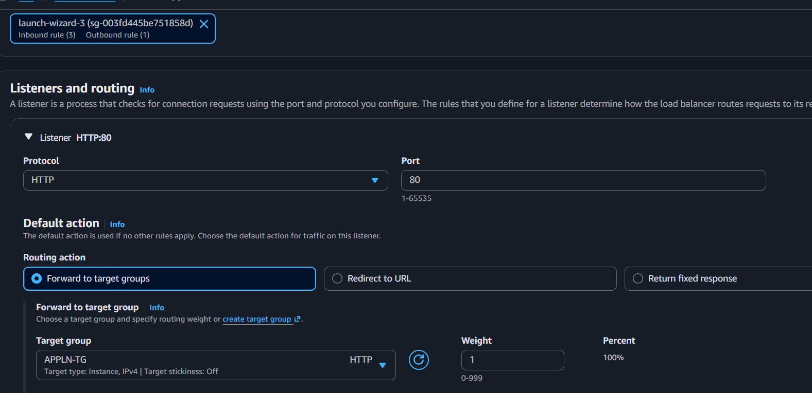

Step 8
Review
Create
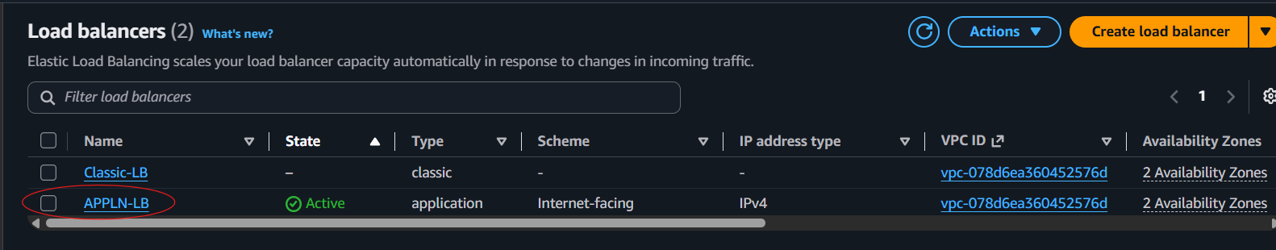
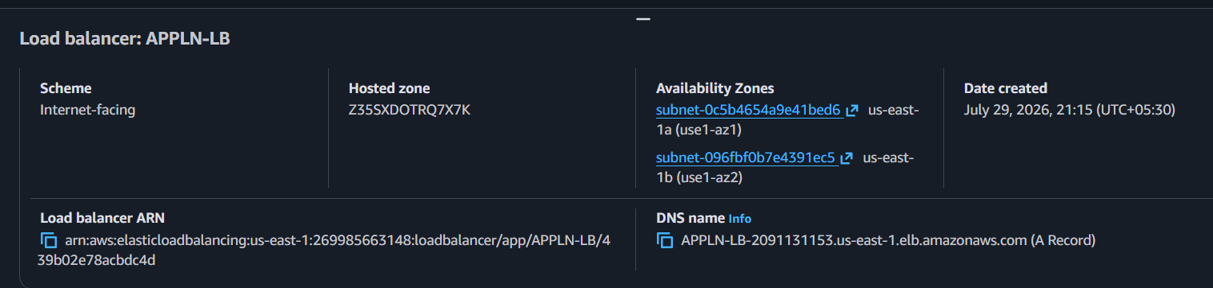

Step 9
Test
Open
http://ALB-DNS-Name
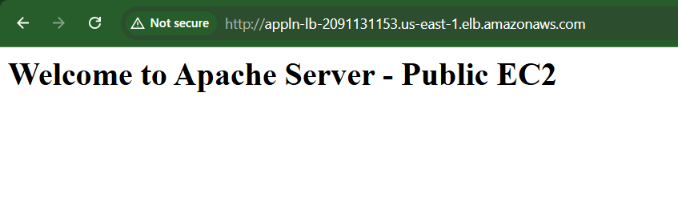
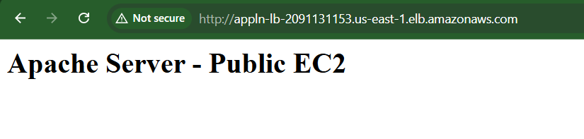

Outcome
- Layer 7 Load Balancer configured.
- Intelligent routing enabled.
- Health checks configured.
- Requests distributed to healthy targets.

Task 3: Configure Network Load Balancer (NLB)

Objective
Deploy a Network Load Balancer to provide high-performance Layer 4 load balancing for TCP/UDP traffic.

Prerequisites
- VPC
- EC2 instances
- Public subnets
- TCP application

Implementation Steps

Step 1
EC2
Load Balancers
Create

Step 2
Choose
Network Load Balancer

Step 3
Basic Configuration
Internet-facing
IPv4
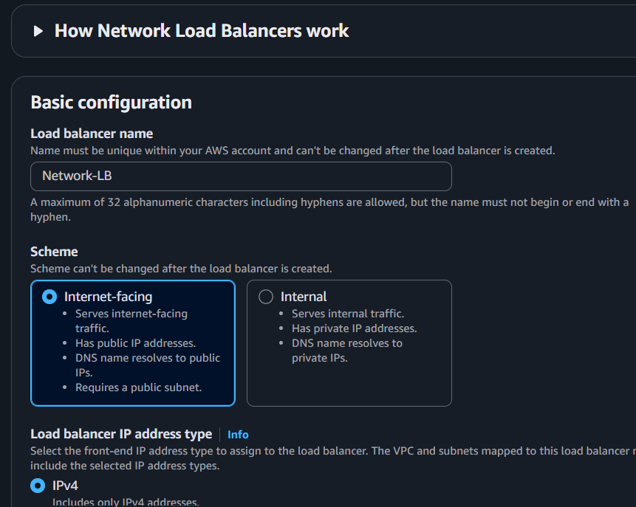

Step 4
Network Mapping
Select
Public Subnets
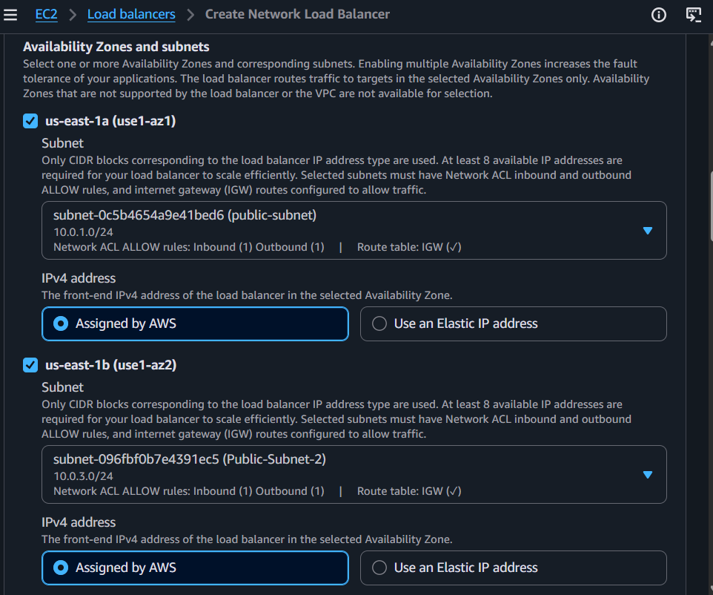

Step 5
Listener
TCP
Port 80
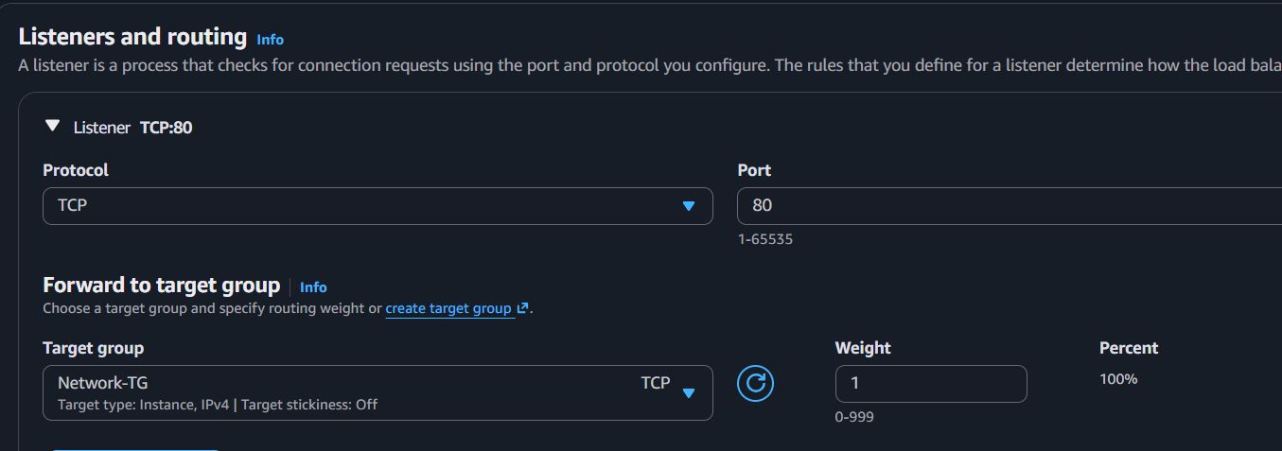

Step 6
Create Target Group
Protocol
TCP
Port
80
Register EC2 instances
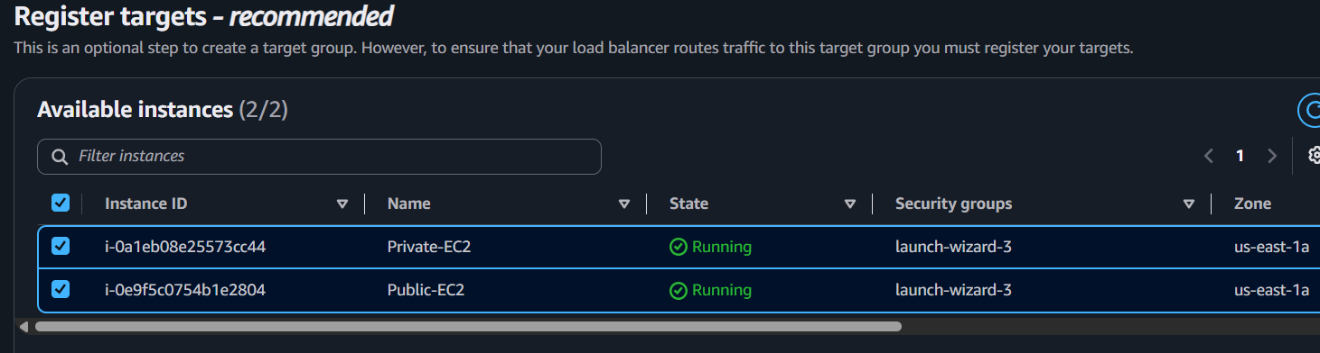
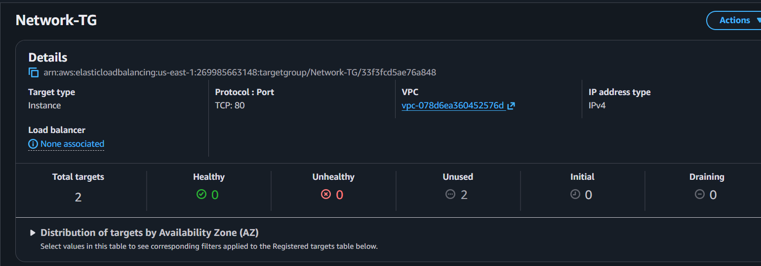

Step 7
Create NLB
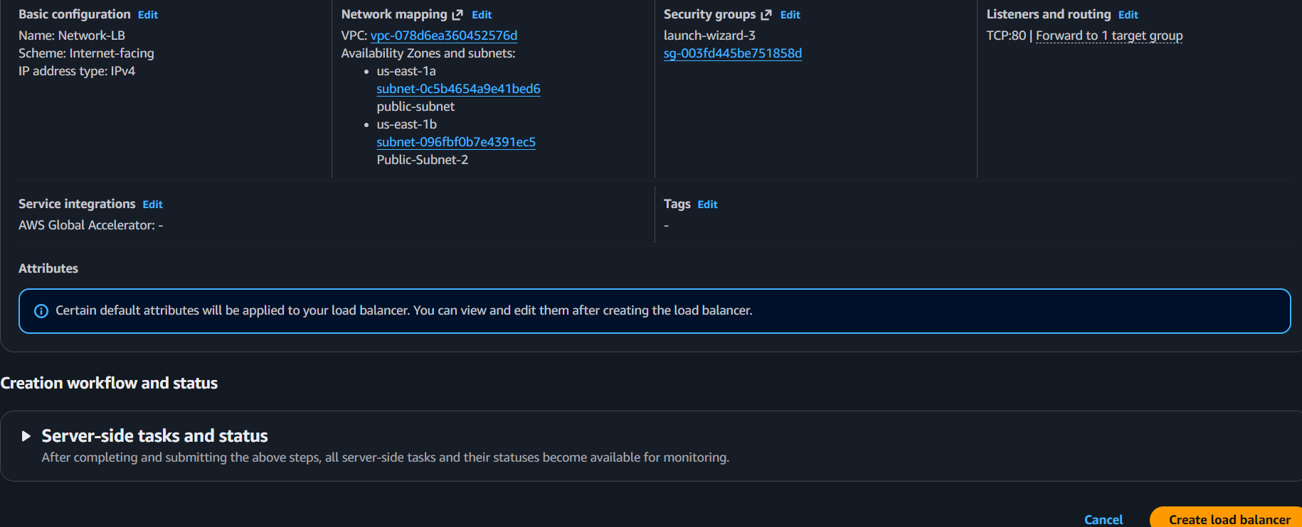
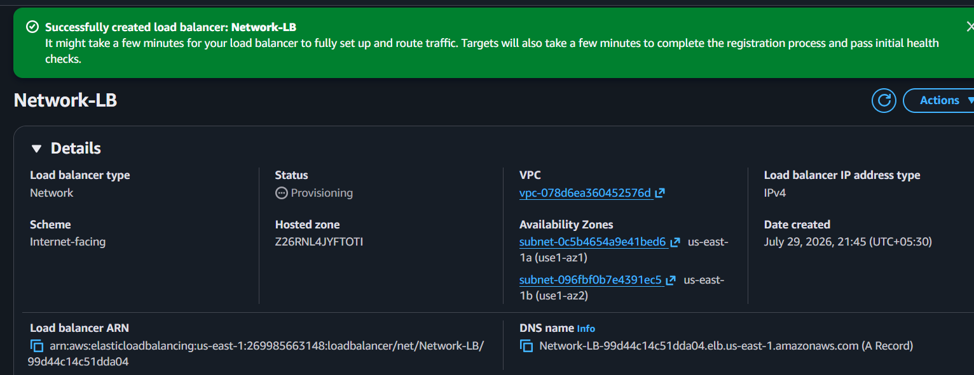

Step 8
Test
http://NLB-DNS
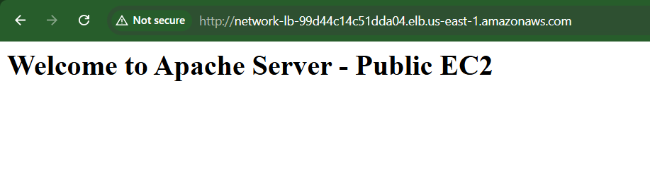
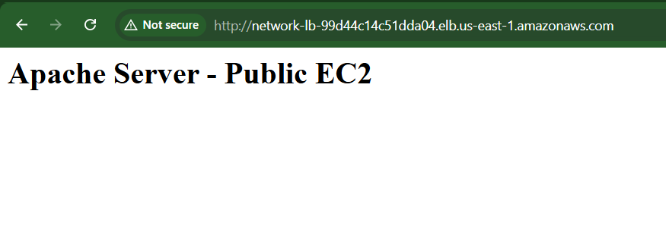

Outcome
- Layer 4 Load Balancer configured.
- High throughput achieved.
- Low latency routing enabled.
- TCP traffic distributed among healthy instances.

Task 4: Attach SSL Certificate to Application Load Balancer

Objective
Secure web traffic by configuring HTTPS on the Application Load Balancer using an SSL/TLS certificate from AWS Certificate Manager (ACM).

Prerequisites
- Application Load Balancer created
- Domain name
- Route 53 hosted zone (or external DNS)
- ACM certificate issued
- Port 443 allowed in the ALB Security Group

Implementation Steps

Step 1
Open
AWS Certificate Manager (ACM)

Step 2
Request Public Certificate
Enter
example.com

*.example.com

Step 3
Validate
DNS Validation

Step 4
Wait until
Status
Issued
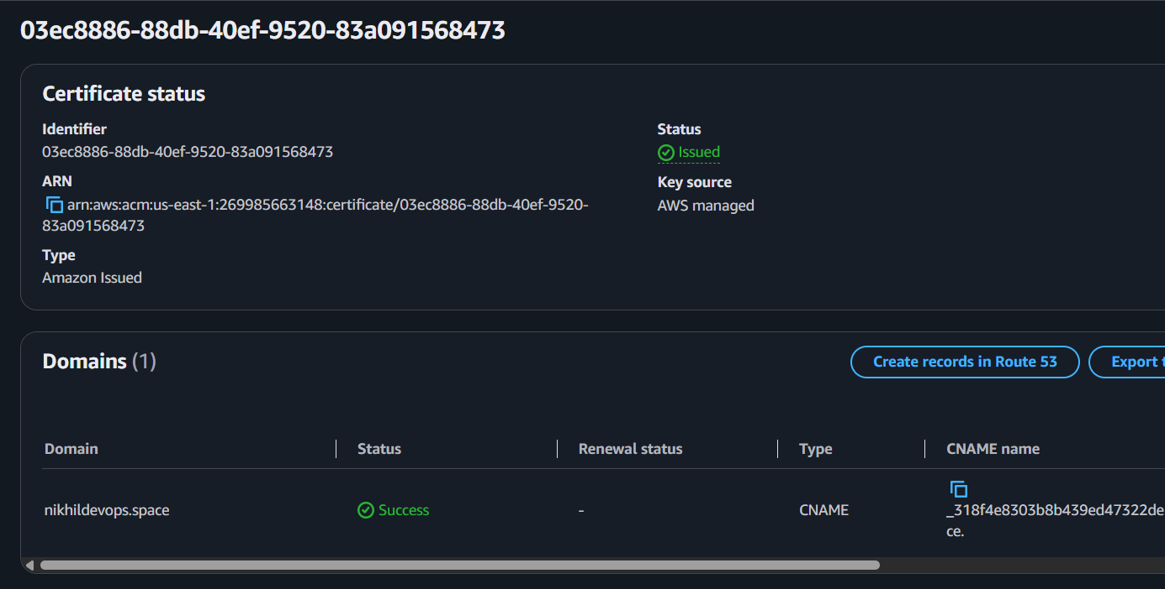

Step 5
Open
EC2
Load Balancers

Step 6
Select ALB
Listeners
Add Listener
HTTPS
443
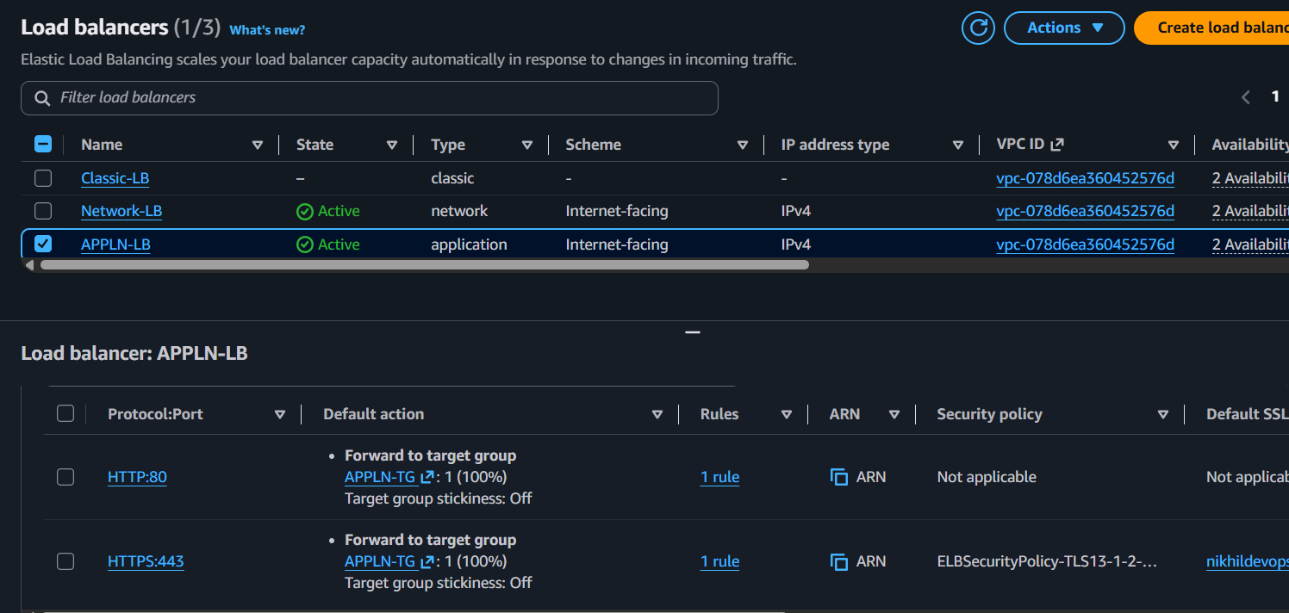

Step 7
Choose
Issued ACM Certificate

Step 8
Default Action
Forward to Target Group

Step 9
(Optional)
Redirect HTTP (80)
→ HTTPS (443)

Step 10
Save

Step 11
Test
https://yourdomain.com

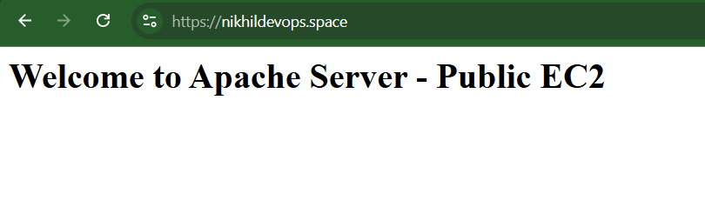
Browser should display the secure lock icon.

Outcome
- HTTPS enabled.
- SSL/TLS encryption configured.
- Secure communication established between clients and the ALB.
- HTTP requests can be redirected to HTTPS.

Task 5: Map Application Load Balancer to Route 53

Objective
Associate a custom domain name with the Application Load Balancer using Amazon Route 53.

Prerequisites
- Domain registered
- Route 53 Hosted Zone created
- ALB created
- SSL certificate attached (recommended)

Implementation Steps

Step 1
Open
Route 53
Hosted Zones

Step 2
Select your hosted zone.

Step 3
Create Record

Step 4
Record Name
Example
www

Step 5
Record Type
A – IPv4 Address

Step 6
Enable
Alias

Step 7
Alias Target
Select
Application Load Balancer

Step 8
Save
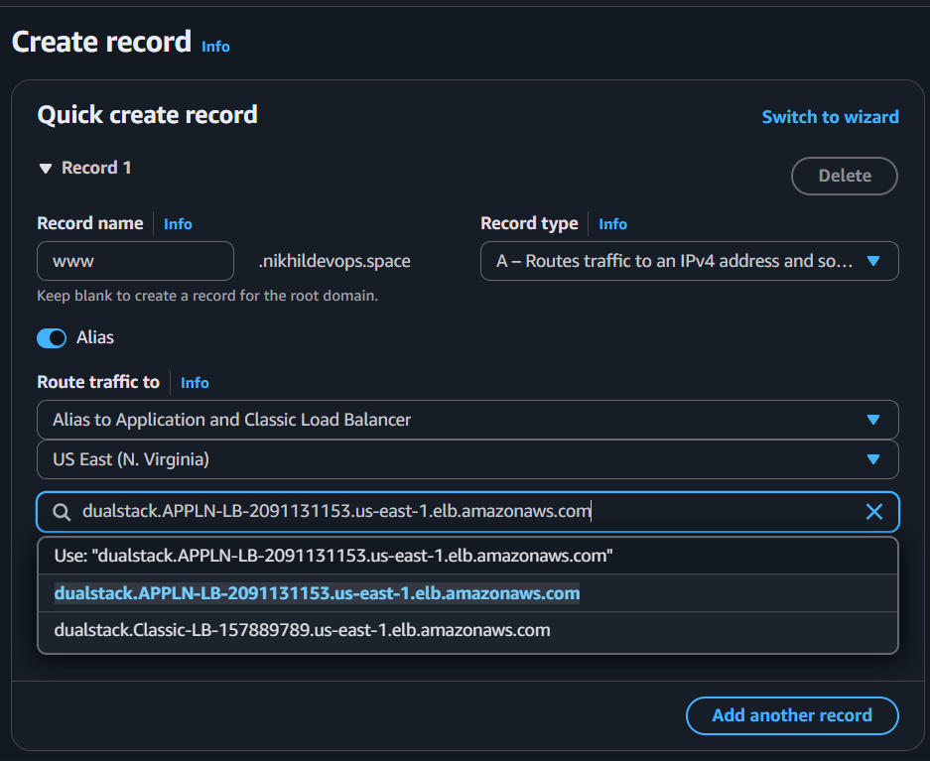
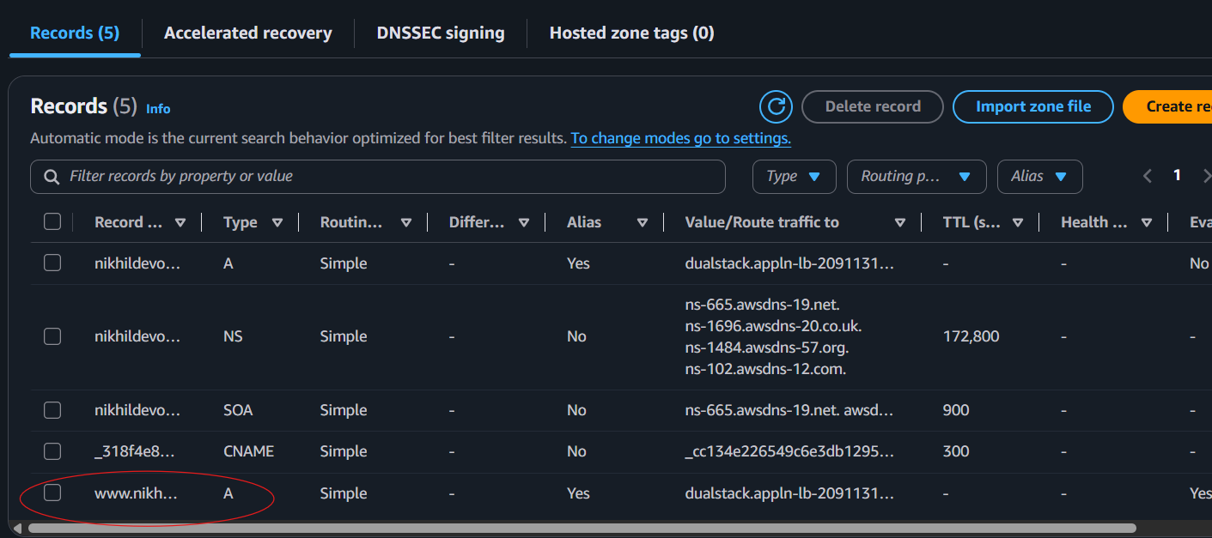

Step 9
Test
https://www.example.com
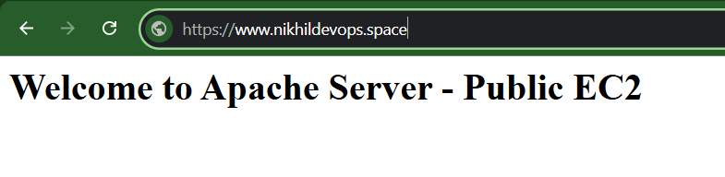
When it executing with www.nikhildevops.space then it is redirecting to Https.



Outcome
- Custom domain mapped to the Application Load Balancer.
- DNS resolution handled by Route 53.
- Users access the application using a friendly domain name.

Task 6: Push Application Load Balancer Access Logs to Amazon S3

Objective
Enable Application Load Balancer access logging and store the logs in an Amazon S3 bucket for auditing, troubleshooting, and traffic analysis.

Prerequisites
- Application Load Balancer created
- S3 bucket created in the same AWS Region as the ALB
- Bucket policy configured to allow the Elastic Load Balancing service to write logs
- Appropriate IAM permissions

Implementation Steps

Step 1
Create an S3 bucket (if not already available).
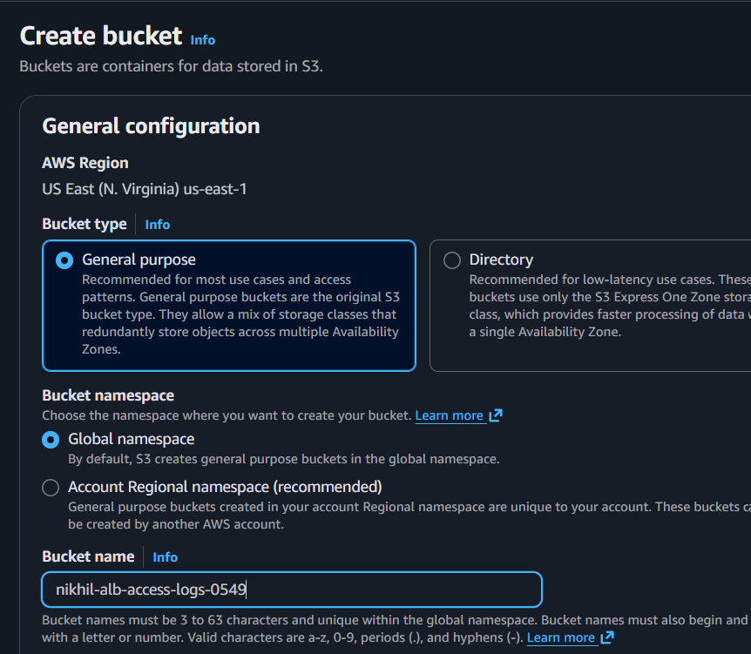 Step 2Add the required bucket policy to allow the Elastic Load Balancing service principal to write access logs. Replace the bucket name and AWS account ID with your own values.
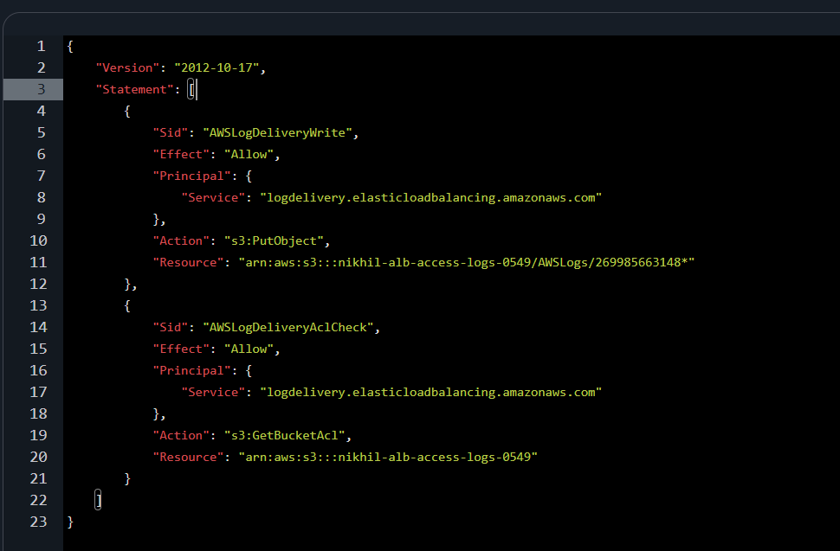

Step 3
Open
EC2 → Load Balancers

Step 4
Select the Application Load Balancer.

Step 5
Choose
Attributes
then click Edit.
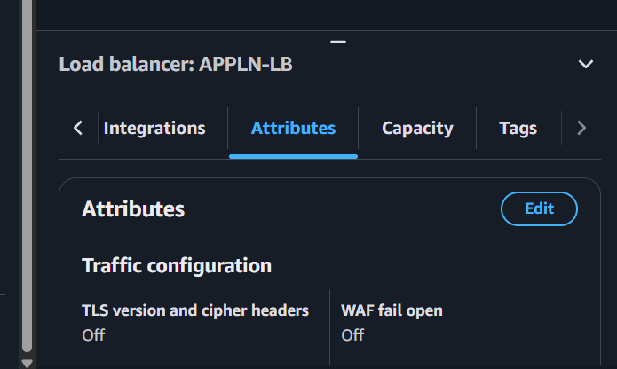

Step 6
Under Access logs:
- Enable Access logs
- Select the S3 bucket
- (Optional) Specify a prefix such as alb-logs/
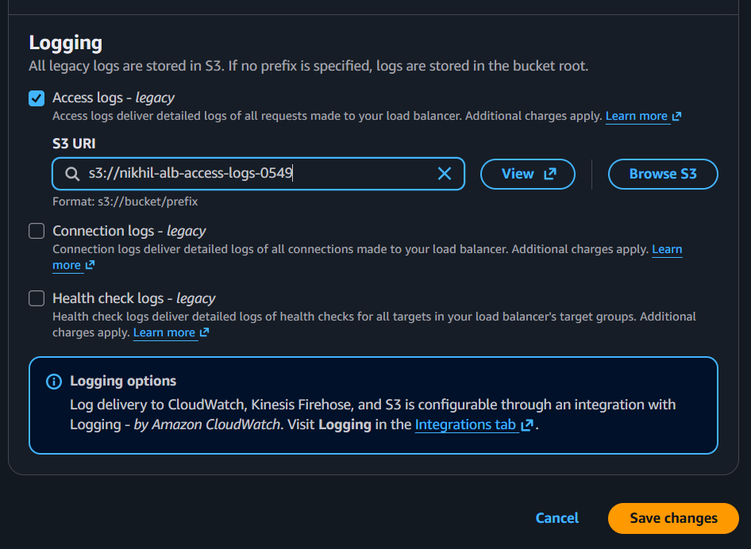

Step 7
Save the changes.

Step 8
Generate traffic by accessing the application through the ALB DNS name or custom domain.

Step 9
Verify that log files are created in the S3 bucket under the specified prefix.
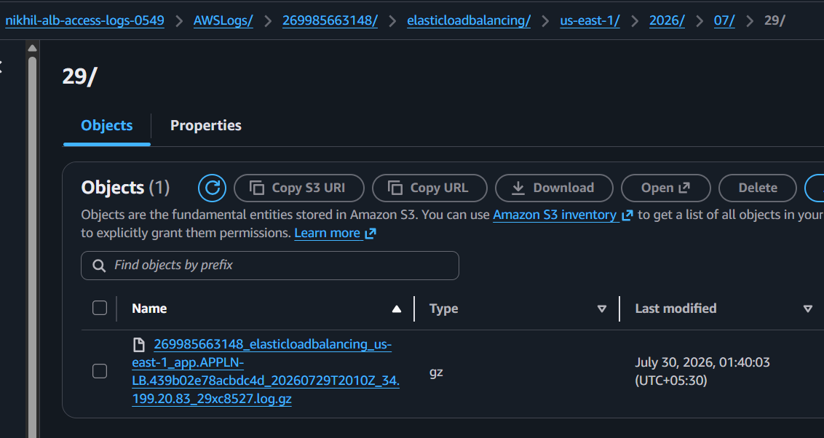

Outcome
- ALB access logging enabled.
- Access logs automatically delivered to Amazon S3.
- Logs available for security auditing, troubleshooting, and analytics.
- Historical request data retained for compliance and operational analysis.

